CMP 464 **CMP 464/788 Fall 2020 Final Project**

**Exploring NYC Open Data**

**Phase II**

**I - The Description of the Project**

The project is to explore NYC Open Data and come out with a conclusion. I have studied **Taxi and Ride hailing Usage in New York City.** This data base is from an analysis of NYC taxi trips <https://toddwschneider.com/posts/analyzing-1-1-billion-nyc-taxi-and-uber-trips-with-a-vengeance/>.

This data is about monthly reports trips of different licenses class such as Green cabs, Yellow cabs, FHV – Black (Uber, Lyft), FHV-Livery (Community Car Service) FHV – Lux Limo and FHV - High Volume. I group those monthly trips reports into year to reduce the shape of the data. Our goal is to know which type of licenses class has more trips during the last 10 years and come out with a proposition to Taxi Limousine Commission (TLC). Based on the hard work and the contribution of this type of license class, the commission should consider these drivers as a city employee.

**II – The Findings of the Project**

**A – The Number of License Class**

The number of license class used for this data analysis are not the same. We can see the illustration in the figure below.

|  |  |
| --- | --- |
| **License Class** | **Number** |
| **FHV - Black Car** | 61 |
| **FHV - High Volume** | 62 |
| **FHV - Livery** | 61 |
| **FHV - Lux Limo** | 61 |
| **Green** | 79 |
| **Yellow** | 122 |

**B – Year and the Number of Trips of each License Class**

The figures below illustrate the distribution of the number of trips of each license class and the year the data has been recorded.

**1 – Yellow Cabs**

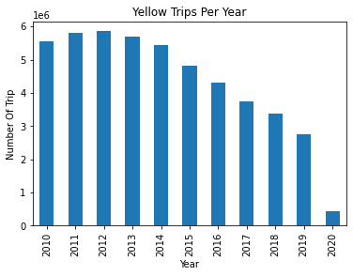

**2 – Green Cabs**

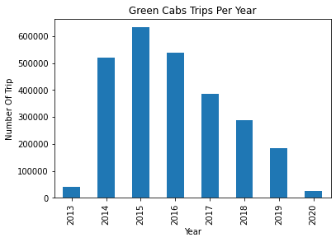

**3 -** FHV – Black

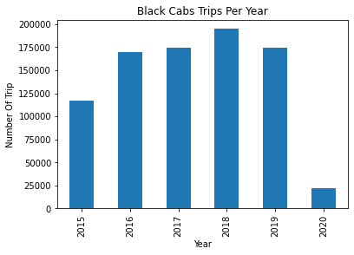

**4 - FHV-High Volume**

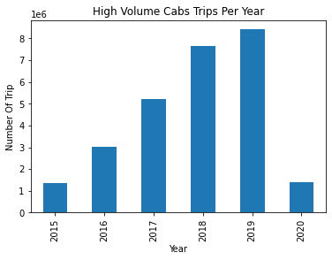

**5 - FHV- Livery**

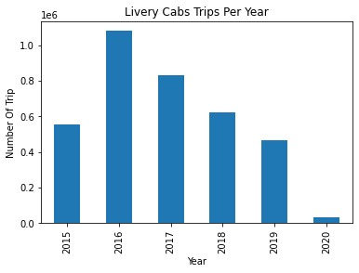

**6 - FHV- Lux- Limo**

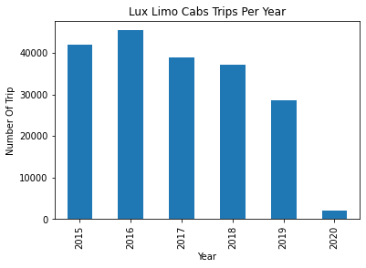

**C – Comparison of the Three Most Cabs Services**

In New York City, we know that the most cabs people are using for their ride are yellow, green, and black cabs. Let see what the distribution

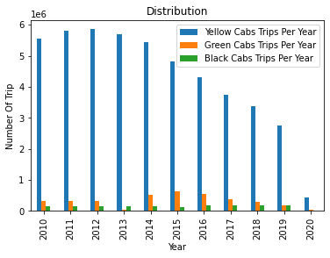

Based on the data, we affirm that yellow cabs are the most cabs ride used in New York City. But we noticed that since 2012 the number of trips is decreasing and completely falling down in 2020. This situation of water falls of can be explained that:

* First, from 2015 to 2019 the number of trips of black cabs has increased
* Second, the health crises of COVID-19 have big negative effect on yellow cab companies. People do not go out any more because of the pandemic restrictions. Bars and clubs are closed so, no passengers for yellow cabs. Airports are closed and many people are scared to travel.
* Third, I would like to point out the surprise of this data I noticed. So, I can add it to the elements the that caused the decreasing of yellow cabs number of trips. The FHV-High Volume number of trips has considerably increased since 2015 until 2019.

**D – Comparison between yellow cab and FHV-High Volume**

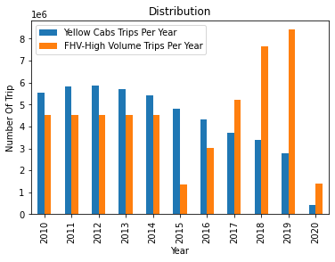

In conclusion, we remarque that yellow cabs face many challengers. Our recommendations to Taxi Limousine Commission (TLC) are to act right now, to integrate yellow cabs drivers as city employee to avoid that thousands of drivers and yellow cabs companies’ employees become unemployed in future.